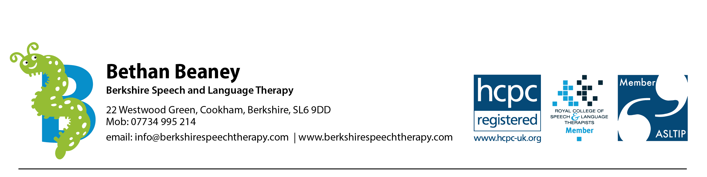

Information for new clients

We want to make your experience of using Berkshire Speech and Language Therapy as easy as possible, therefore this information sheet lets you know how to find us and what to expect from your sessions.

Where is the clinic?

Most sessions take place at Elizabeth House, Station Road, Cookham, SL6 9BS, which is primarily a Centre for the Elderly, where we have a clinic room. Some sessions take place at your child’s nursery and school or occasionally at your home. This is the link to the Elizabeth House website: Home | Elizabeth House Cookham

If your session is taking place at Elizabeth House, please park in the Shopping Parade car park, which is a short walk from Elizabeth House. (Parking at Elizabeth House is prioritised for the elderly clients using the facilities). Parking at the parade is free for 1 hour 45 minutes.

If Dawn Seeney, is on reception, please let her know you have arrived and sign in. She will direct you to the waiting area upstairs. Do please knock on the door to let me know you have arrived and then take a seat in the waiting area. If you have any issues finding the clinic, please call me on 07734995214.

What can I expect from a speech and language therapy session?

Some children can be quite shy when they come to meet me, therefore I like to allow up to 10 minutes for the child to relax by playing with you. During the session, if your child doesn’t speak very much, this is fine; it’s important that your child feels as relaxed as possible and I can gain lots of information from their play and from discussion with you.

I will attempt some assessment tasks; some of these involve sitting and looking at pictures together; some involve play with toys; some tasks may involve copying me saying sounds and words. During this time, I ask that parents support their child, but that you don’t try to rephrase questions that I have asked, unless I ask you to, as this will affect the results. I will always ask parents if their child’s communication during the assessment session reflects how they are at home.

I aim to make therapy sessions fun, to engage your child and so they get the most out of therapy tasks. I will usually talk to parents for the final 10 minutes of the session, whilst your child plays, to give a summary of my findings and make recommendations regarding next steps. I aim to finish sessions promptly to ensure you and your child are not left waiting at the start of the session and that the session doesn’t over-run and your child becomes tired/hungry.

If you have any questions, please feel free to ask me. I look forward to meeting you and your child and supporting you in enhancing their communication skills.

Bethan Beaney, Speech and Language Therapist

October 2025

